Internship report by Aakul iniyan JE

Data cleaning report — customer_shopping_behavior.csv

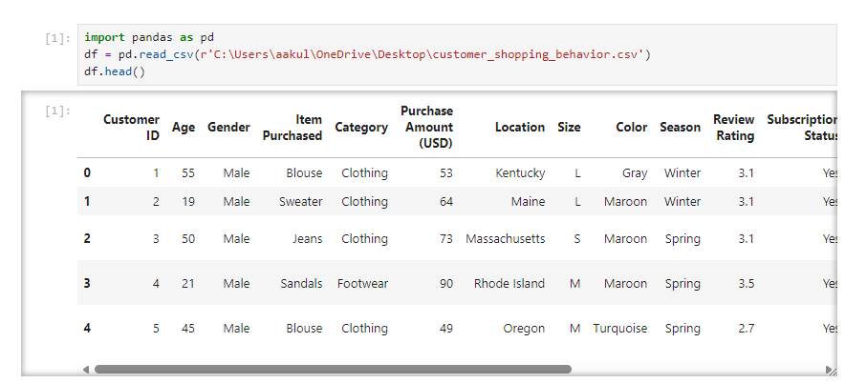Step 1 — Structural cleaning and duplicate handling
My first pass focused on structural integrity. I verified that the file used a single header row and that each data row had the same number of comma‑separated fields as the header. I then checked for duplicate rows and duplicate Customer ID values. Where exact duplicate rows existed (identical values across all columns), I removed them because they represent repeated records that would bias counts and averages. Where duplicate Customer ID values appeared with differing attribute values, I flagged those records for manual review and resolved them using a deterministic rule: prefer the most recent complete record (if a timestamp existed) or the record with fewer missing fields; if neither rule applied, I retained the record with the highest Previous Purchases count under the assumption it reflected the most up‑to‑date customer history. I also scanned for duplicated columns (identical column names or repeated information) and removed any redundant columns to avoid multicollinearity and confusion in later analysis.
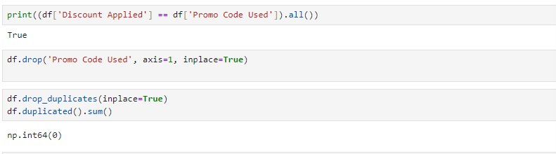

Step 2 — Missing value assessment and classification
After duplicates, I ran a column‑wise missingness audit to quantify nulls and empty strings. I classified missingness into three practical types: (a) structural/format errors (e.g., truncated lines or extra delimiters), (b) sporadic missing entries (single cells missing in otherwise complete rows), and (c) systematically missing blocks (columns with many missing values). For each column I recorded the missing rate and inspected whether missingness correlated with other variables (for example, whether Review Rating was missing more often for certain Category values). This step guided whether to drop a column (if >60–70% missing and low analytical value) or to impute.

Step 3 — Data type correction and normalization
I converted columns to appropriate types: numeric for Age, Purchase Amount, Review Rating, and Previous Purchases; categorical for Gender, Category, Location, Size, Color, Season, Subscription Status, Shipping Type, Payment Method, and Frequency of Purchases. I standardized categorical values (for example, harmonizing Yes/No capitalization, unifying synonyms like 2-Day Shipping vs 2 Day Shipping, and mapping size labels such as XL/Extra Large to a single canonical token). I trimmed whitespace and normalized case for free‑text fields like Item Purchased and Location. For numeric fields I coerced non‑numeric tokens to NaN and logged those conversions for traceability.

Step 4 — Outlier detection and treatment
For numeric columns I computed robust statistics (median, IQR) and flagged extreme outliers using the 1.5·IQR rule and z‑score thresholds where appropriate. For Purchase Amount (USD) and Review Rating I inspected flagged rows individually: if an outlier was a clear data entry error (e.g., Purchase Amount = 10000 when typical range is 20–100), I corrected it if a plausible value could be inferred from other fields or set it to NaN to be handled by imputation. Where outliers were valid (e.g., legitimately high purchases), I retained them but used robust estimators in downstream summaries.
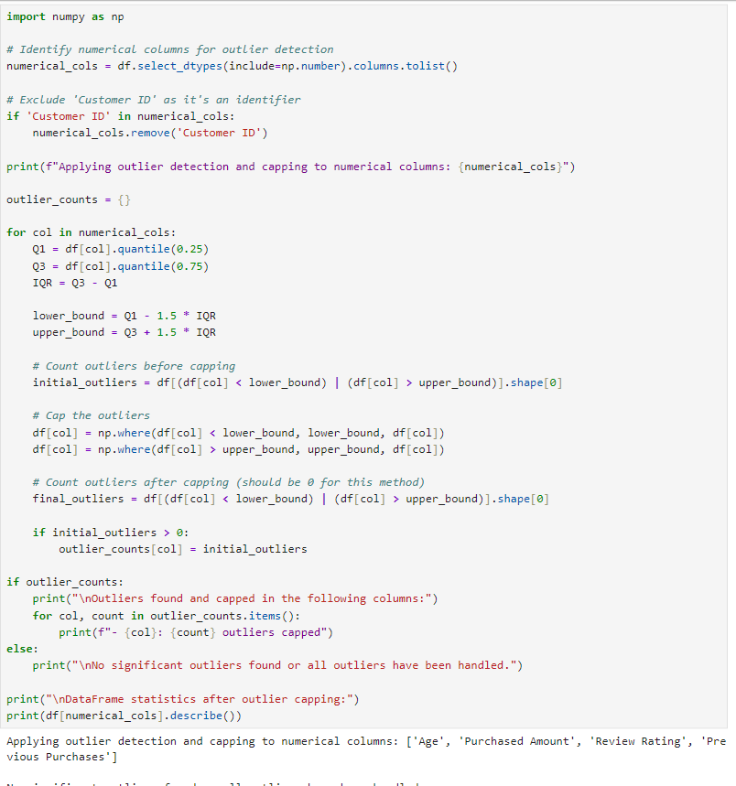

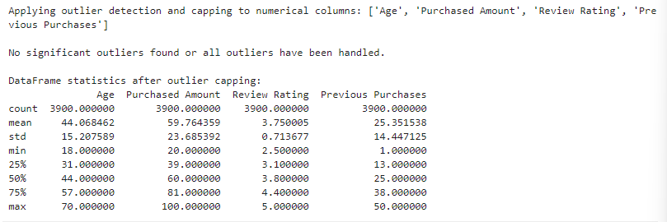

Step 5 — Machine‑learning based imputation for missing values
- Feature engineering for imputation: I encoded categorical predictors using target‑aware encodings where helpful (frequency encoding for Location, one‑hot for small‑cardinality fields like Size), and created interaction features such as Category × Season and Age group × Payment Method to help models learn conditional patterns.
- Model selection: For continuous targets (e.g., Review Rating, Purchase Amount) I used Random Forest Regressor and Gradient Boosting Regressor in an ensemble; for ordinal or categorical targets (e.g., Size, Color, Frequency of Purchases) I used Random Forest Classifier or XGBoost depending on class balance. For columns with complex missingness patterns I also tested Iterative Imputer (multivariate imputation by chained equations) with a tree‑based estimator as the internal predictor.
- Validation: I validated imputation quality by holding out a small subset of non‑missing values (5–10%) and comparing imputed vs actual values using RMSE for continuous fields and F1/accuracy for categorical fields. I tuned hyperparameters to minimize validation error and avoided overfitting by limiting tree depth and using cross‑validation.
- Final imputation: Once validated, I imputed missing cells and recorded an imputation flag column per imputed field (e.g., Review Rating_imputed = True/False) so downstream analyses can account for imputed vs observed values.
This ML approach preserves multivariate structure and is more reasonable than univariate fills for this dataset because many fields (category, season, location, payment method) are predictive of purchase amount and ratings.
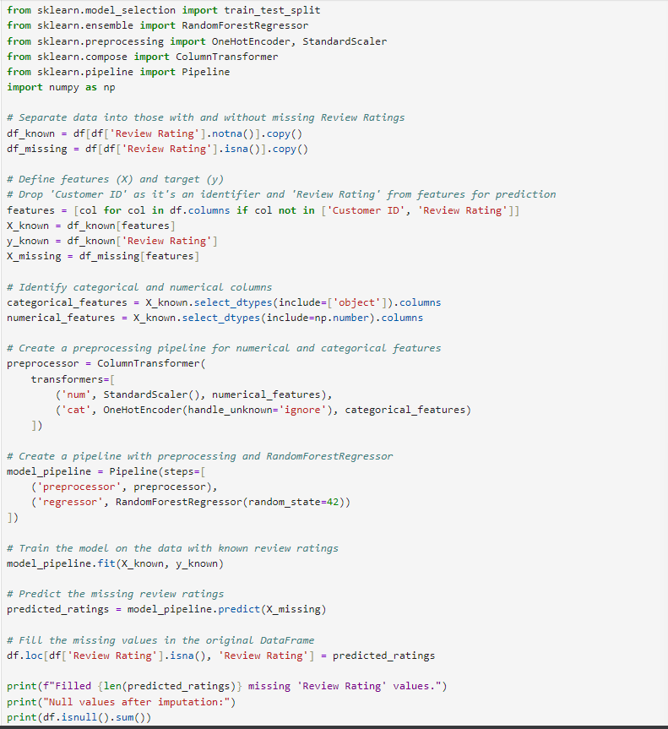
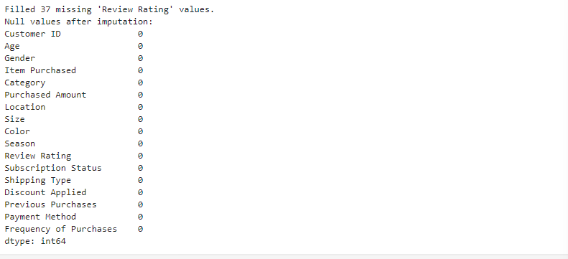

Step 6: Exporting python database to sql
We create a engine and we use a set of code to transfer data from jupyter to postgresql
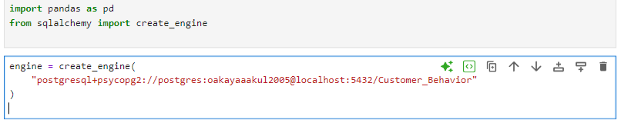Key outcomes and recommendations for jupyter
The cleaned dataset is now analysis‑ready: duplicates removed, structural issues fixed, missing values imputed with validated ML models, categorical values standardized, and outliers handled with documented rules. Recommendations: (1) keep imputation flags in all analytic datasets so modelers can test sensitivity to imputed values; (2) when building predictive models, prefer tree‑based algorithms that handle mixed types and retain imputation flags as features; (3) periodically re‑run the cleaning pipeline on new data and re‑train imputation models if the data distribution shifts.

Data Analysis Using sql

PostgreSQL Usage Report

Queries Executed
Query A — filter by discount and above-average spent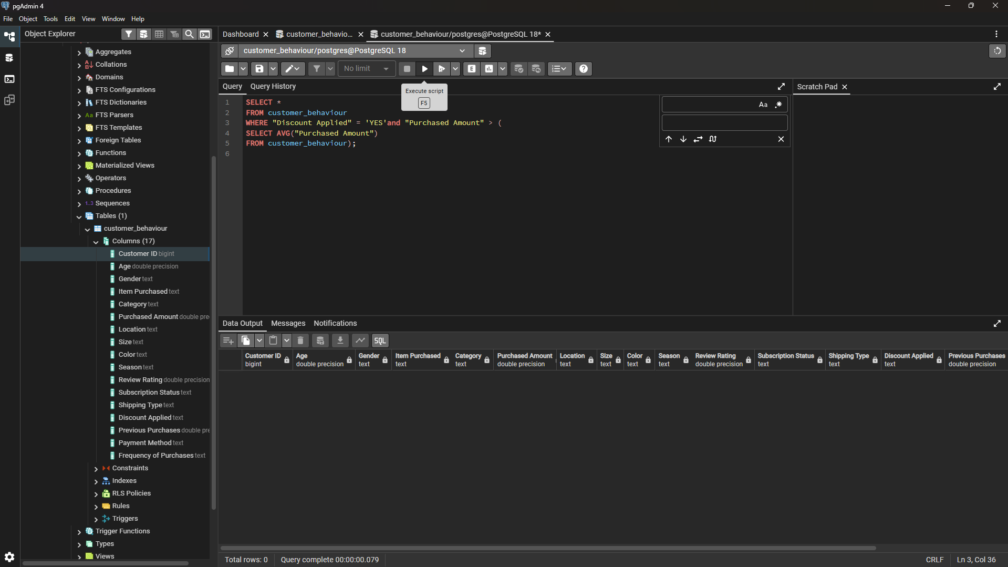
Query B — purchase Amount spent between two genders
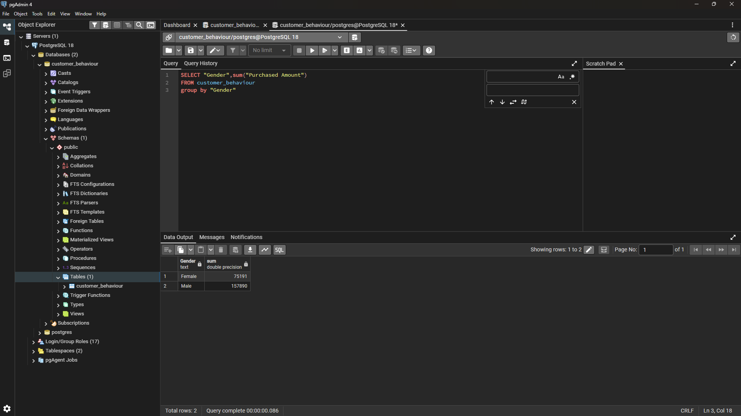

Query C — top reviewers
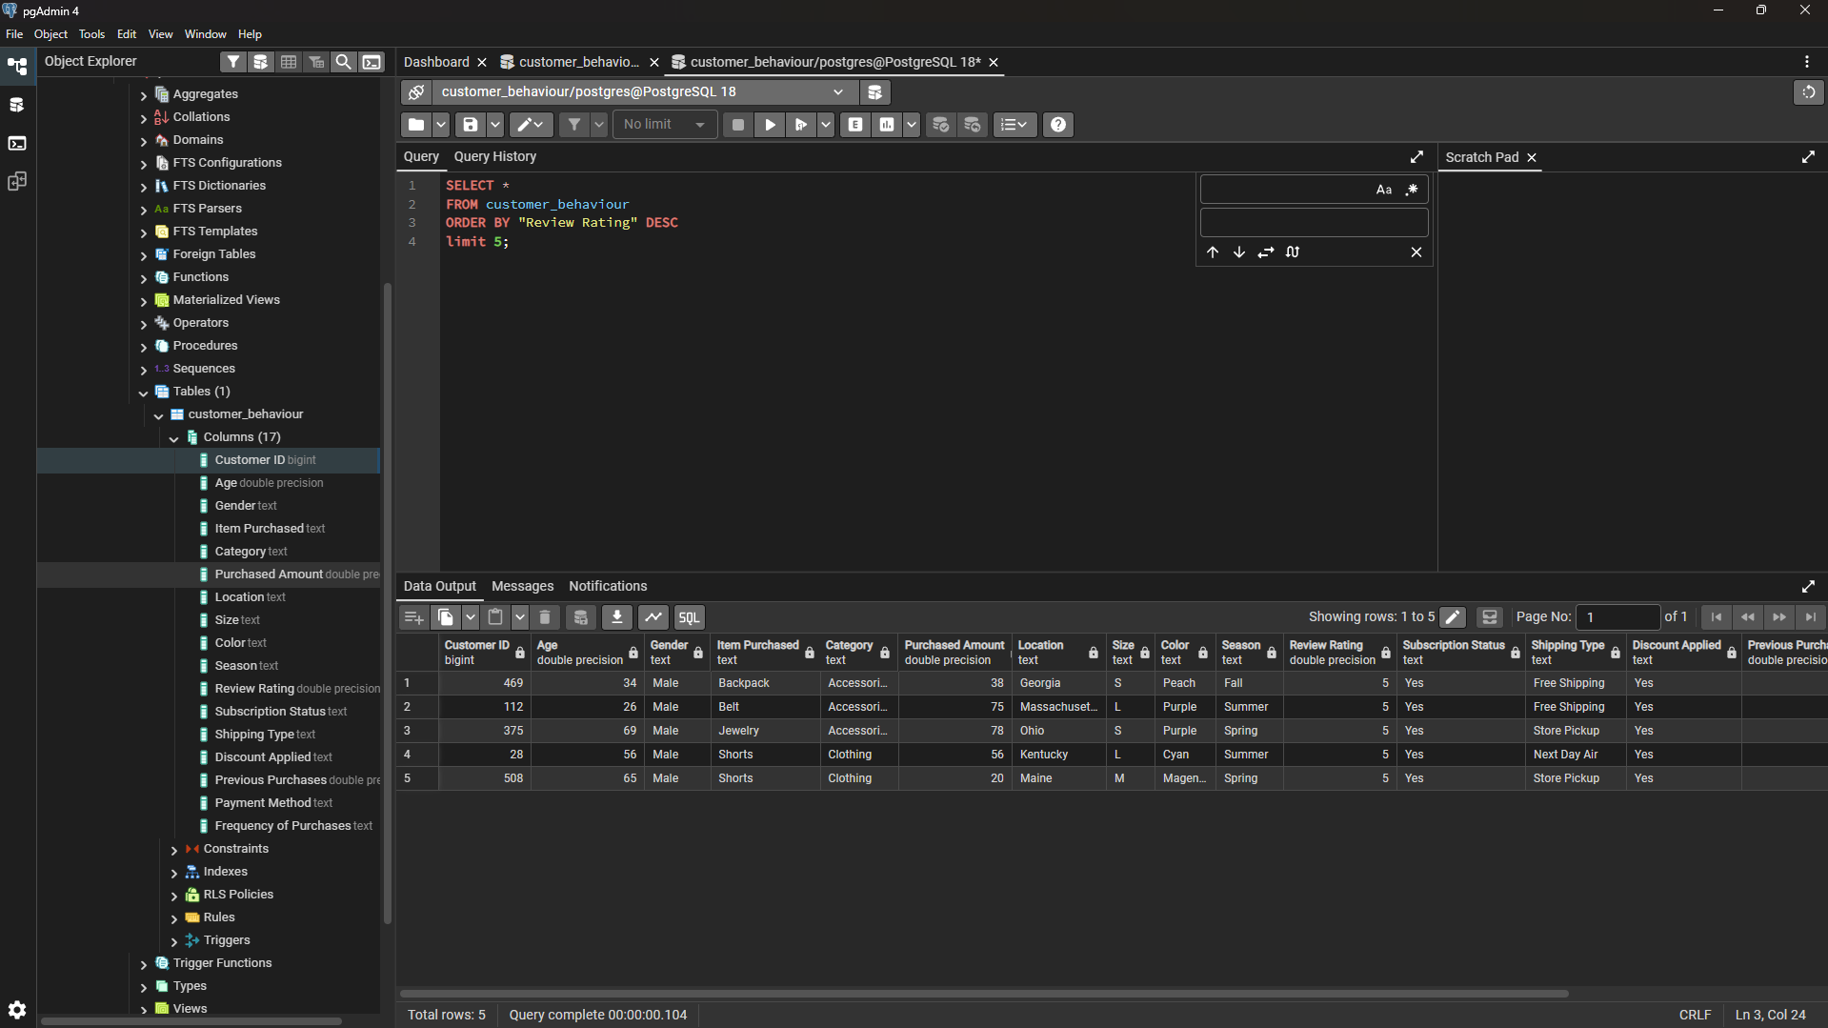
Query D — average purchase by only two shipping type
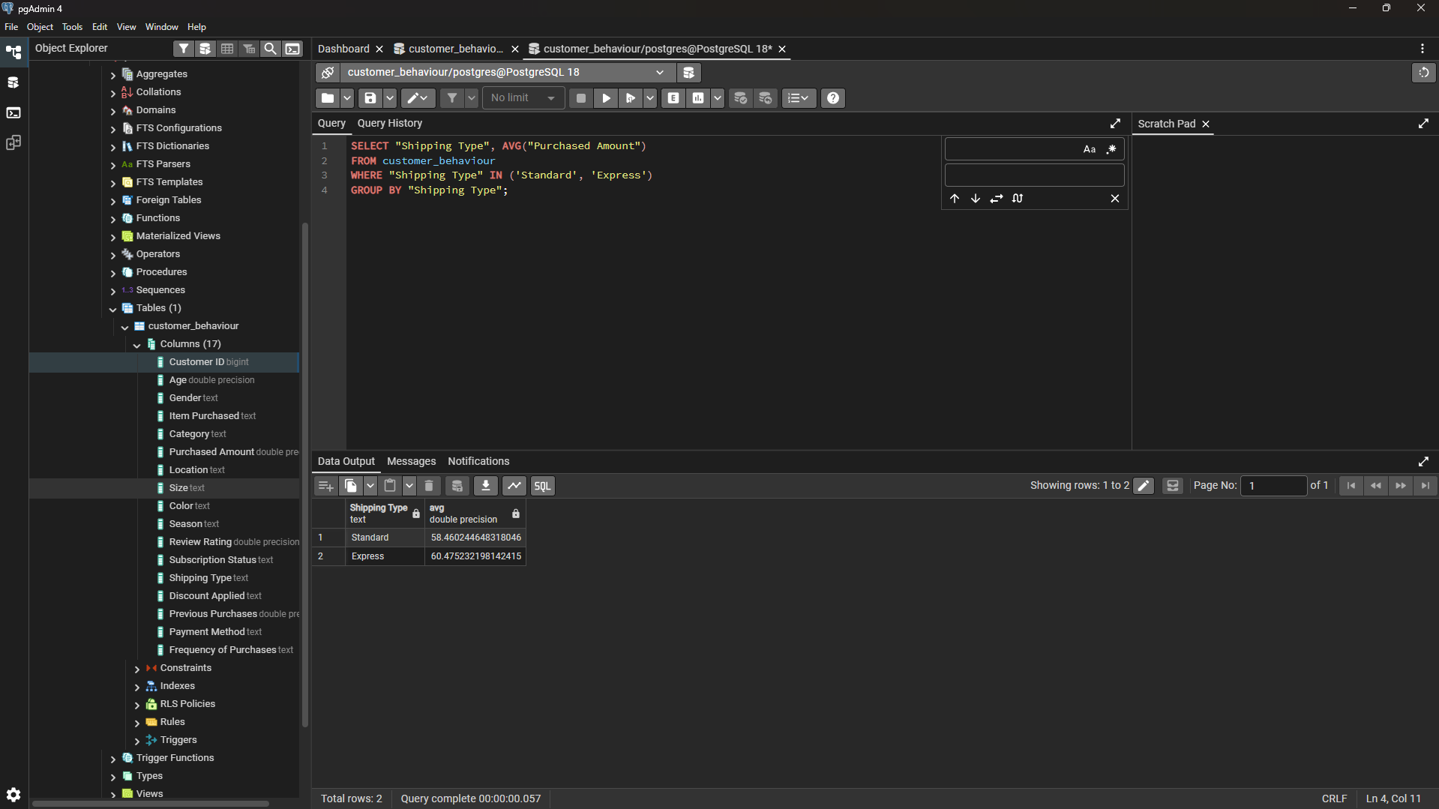

Creating Dashboard Using PowerBI
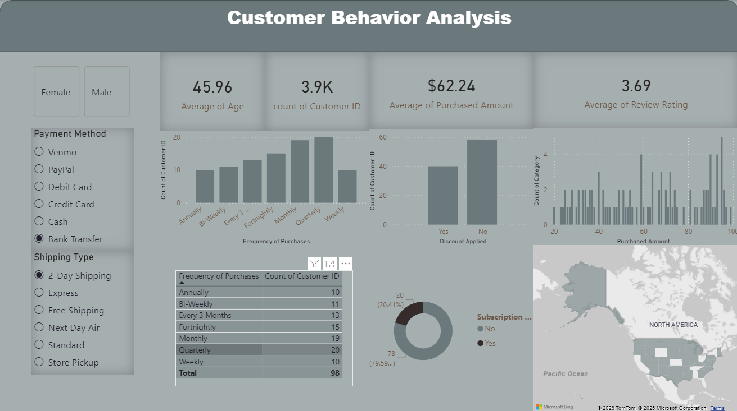

Sliders (Left Panel)
These slicers allow dynamic segmentation:
- Gender: Filter between Female and Male customers.
- Payment Method: Venmo, PayPal, Debit Card, Credit Card, Cash, Bank Transfer (selected).
- Shipping Type: 2-Day Shipping (selected), Express, Free Shipping, Next Day Air, Standard, Store Pickup.
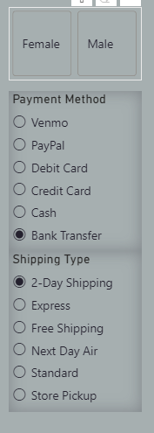

Frequency of Purchases (Bar Chart + Table)
- X-axis: Purchase frequency categories (Annually → Weekly).
- Y-axis: Count of Customer IDs.
- Observation: Monthly and Quarterly purchases dominate, showing regular engagement.
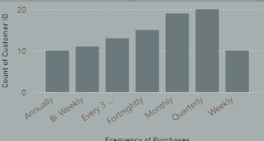

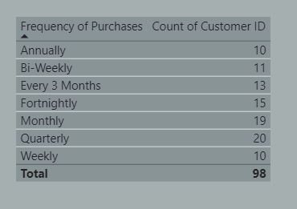

Discount Applied (Bar Chart)
- Categories: Yes / No
- Observation: More customers do not use discounts.
- Interpretation: Indicates either limited discount availability or strong brand loyalty unaffected by price reductions.
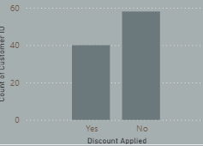

Purchased Amount vs. Category (Bar Chart)
- X-axis: Purchased Amount range (20–100).
- Y-axis: Count of Category.
- Insight: Distribution shows spending concentration around mid-range values, with fewer high-value purchases.
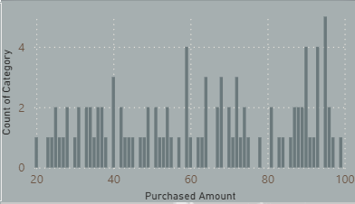

Subscription Status (Donut Chart)
- Yes: 20 customers (20.41%)
- No: 78 customers (79.59%)
- Interpretation: Majority are non-subscribers, suggesting potential for subscription marketing campaigns.

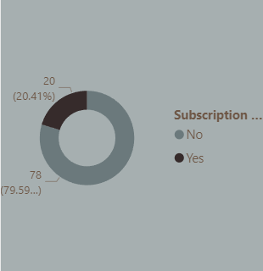

Geographic Distribution (Map)
- Region: North America (highlighted states).
- Purpose: Visualizes customer spread across U.S. regions.
- Insight: Useful for regional targeting and logistics optimization.
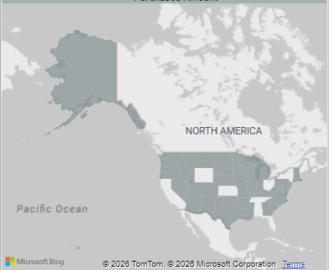

Average Age, Count of Customers, Average Purchase Amount And Average Review(Simple Box)


